The Art of Sales: Fundamentals of Selling
I completed the HP LIFE online course “The Art of Sales: Fundamentals of Selling.” In this course, I learned about sales skills, customer communication, handling objections, and understanding customer needs. I also received a certificate after completing the course.
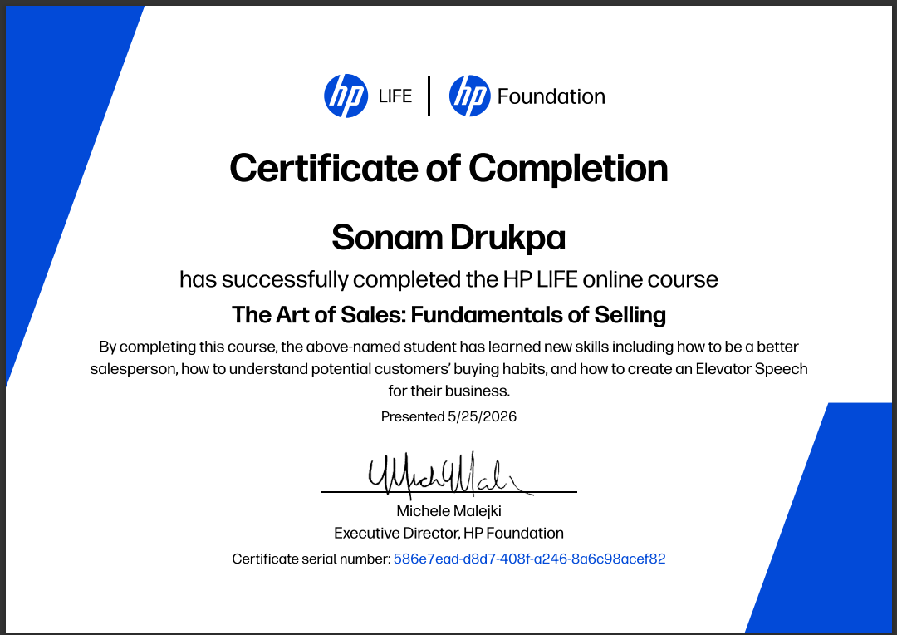
Thank You

